# New Features

1. Trash Service: Sending Emails (Inbox, Sent, Draft) to trash.

URL: <http://localhost:8080/EmailApp/rest/TrashBox/DeleteEmail>

With DELETE request and JSON body as

{"userId":2,"emailID":7,"boxType":"Inbox"}

Identifying the userid, emailed and whether it belongs to Inbox/Sent/Draft

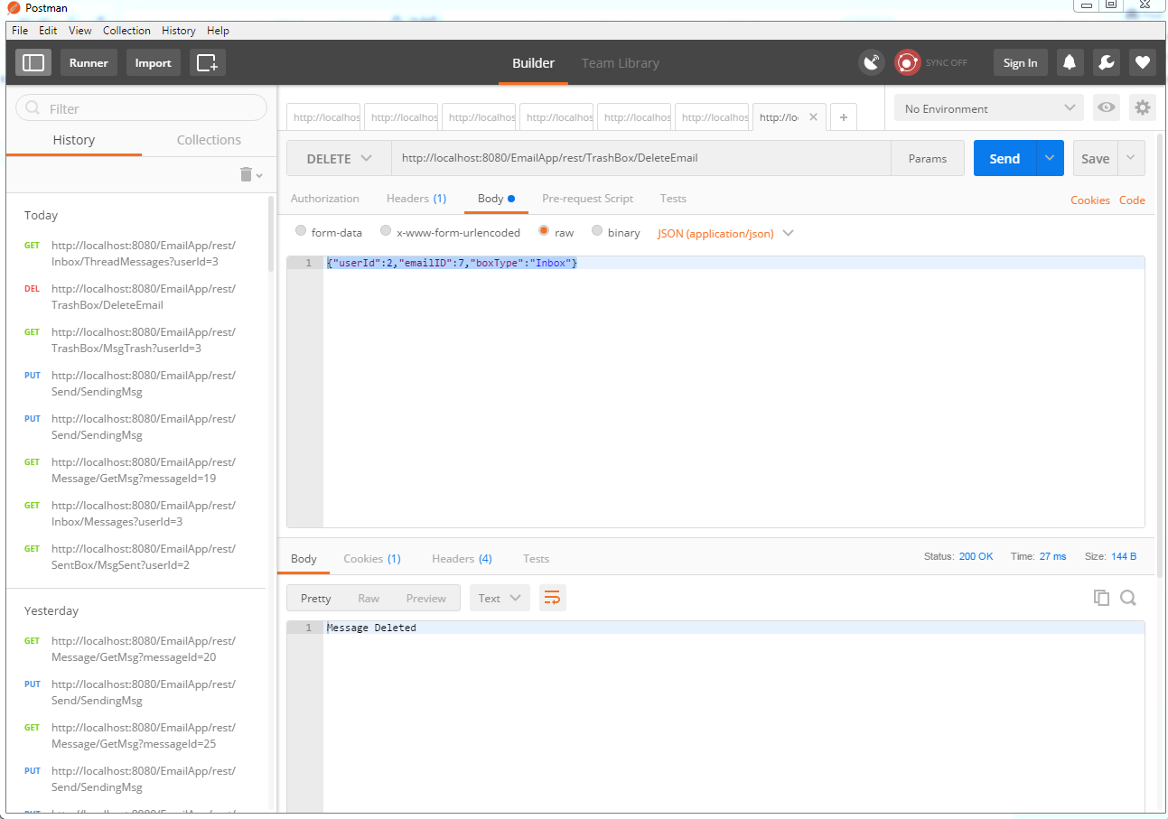

1. Thread Service: This has only been implemented for Inbox i.e. emails will be fetched in thread format i.e. all emails in 1 thread will be in one list of emails and there will be first 20 threads once you call this service.

URL: <http://localhost:8080/EmailApp/rest/Inbox/ThreadMessages?userId=3>

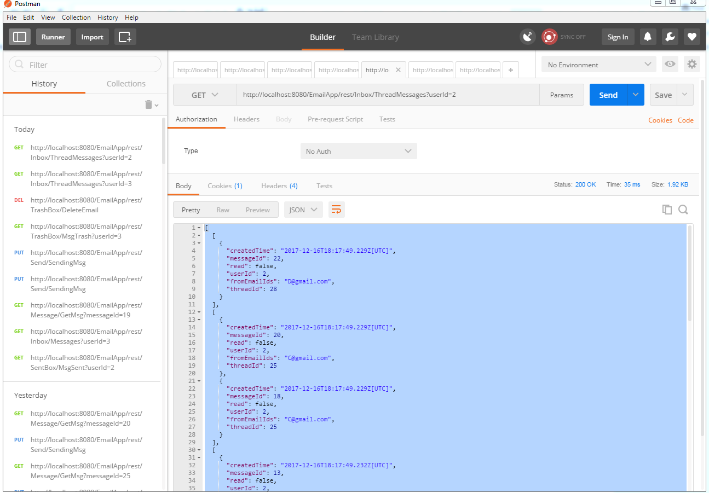

1. Updated Send Email Service

I have added new feature in Send Mail Service for thread Id and inbox ID.

If these two fields are added inbox will be updated with this thread id and the historic message i.e. last message for same user id with same thread Id will be appended to this new message.

{"subject":"Testing!","message":"This is my followup thread test message!!!","userId":4,"toUserIds":"2", "threadID":28, "inboxID":28}

If these fields are not present thread Id will be same as inbox id thus being unique automatically.

{"subject":"Testing!","message":"This is my test added thread test message!!!","userId":6,"toUserIds":"4"}

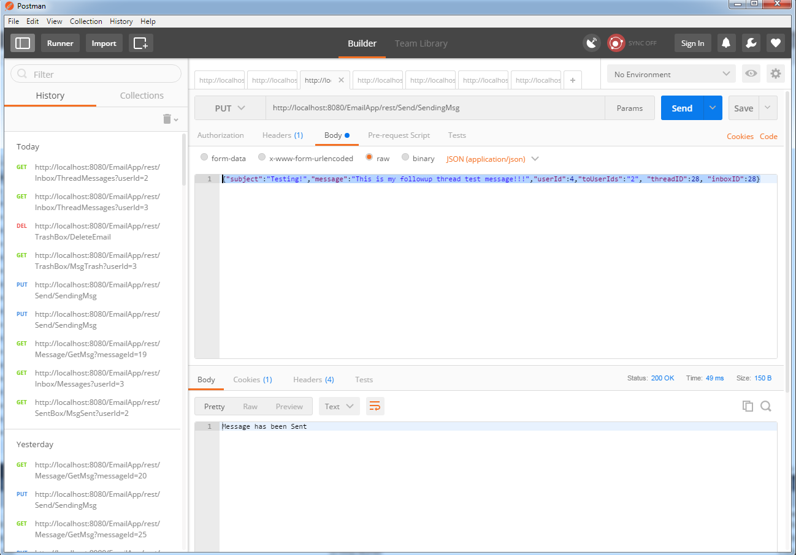

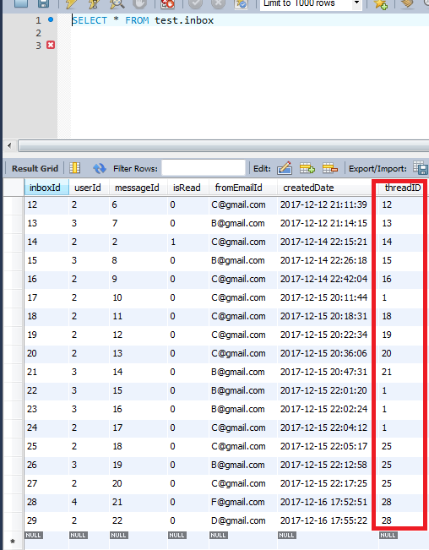

Figure 1Thread Id added to Table

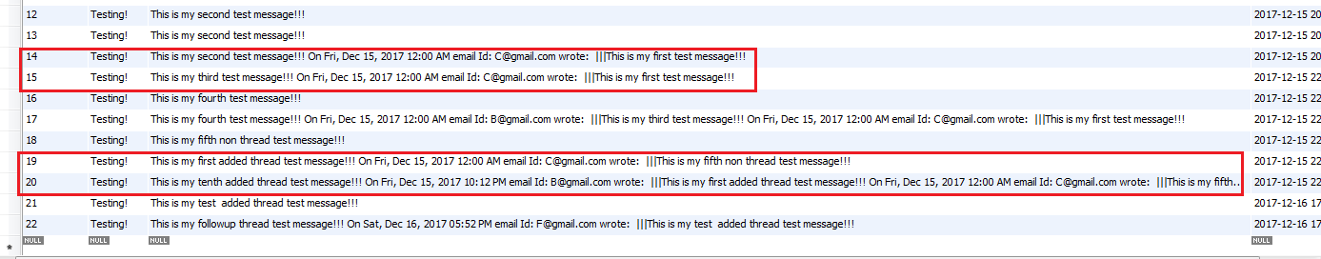

Figure 2: Multiple Level Appending